**EEC 134 Group Application Note**

**Team James**

**Kent Tanita, Kevin Tang, Kristy Yeung**

**Table of Contents:**

1. Abstract
2. Introduction
3. Component Selection
4. Design Schematics
5. Printed Circuit Board Designs
6. Testing the System
7. Antenna Design
8. Possibility for future extension
9. Suggestions for the class
10. Conclusion

**1) Abstract:**

The goal of this project was to design a frequency modulated continuous wave (FMCW) radar system that is capable of determining the distance or range of an object. The distance of an object is determined by examining the difference in frequency between the transmitted signal and the received signal. As for measuring the speed of an object, the transmitted signal is fixed at one frequency. Once the signal hits the moving target, the reflected signal’s frequency is shifted due to the Doppler Effect, and from that the speed of the moving object may be determined. The operating frequency for our design is 5.8 GHz and the design is composed of two printed circuit boards, one board for the baseband and one for the RF components. Rather than using a digital signal processor for testing, the board was tested on a computer through the use of Audacity and Matlab in order to determine the distance and speed of an object.

**2) Introduction:**

The frequency modulated continuous wave radar is a short- range measuring radar with the ability to measure distances, target range and its relative velocity. The frequency modulated continuous wave (FMCW) radar is a continuous wave (CW) radar system that is frequency modulated. In contrast to the CW radar, the FMCW radar is capable of receiving information about the range to target through the modulation of frequency of a transmission signal. The frequency continuous wave varies in frequency with respect to a fixed period of time by a modulating signal such as the sawtooth, triangle, square-wave, and sinusoidal (Fig 1).

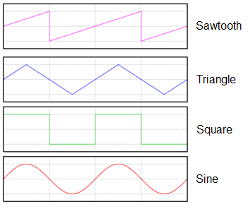

Figure 1

The frequency change is achieved by ramping up and down the $V_{tune}$ voltage of the VCO in the radar transmitter. When the radar signal leaves the transmitting antenna, the frequency will not change because the transmitter VCO continually ramps up and down. As the signal is reflected back to the receiver of the radar, the radar will observe the difference in frequency out of the transmitter. The differences in frequencies of the transmitted and received signals enable the determination of the distance to an object.

In this radar application, the triangle wave was chosen as the modulation pattern. This modulation pattern allows for an easier analysis of the frequency difference between the received and transmitted signal enabling the determination of both range and velocity (Fig 2).

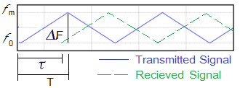

Figure 2

As shown in figure 2, the received signal (dashed green line) is a delayed form of the transmitted frequency (solid blue line). The distance of objects can be determined by finding the time difference of the transmitted signal from the radar to the target can be determined by

$$t=\frac{d}{c}$$

where t is the time it takes for the transmitted signal to reach the target, d is the distance to the target, and c is the speed of light $c=3*{10}^{8} m/s$. The total time it takes for the transmitted signal to reach the target and back to the radar is given by

$$t=\frac{2d}{c}$$

where the frequency of the transmitter has changed by ∆*f,* the change in frequency.

$$Δf =k*\frac{2d}{c}$$

where k is the rate at which the frequency ramps up and down. $Δf$ can be measured by passing the received signal and the transmitted signal through a mixer. The difference between the transmitted signal and the received signals is the intermediate frequency. The Intermediate frequency represents the parameters of beat frequency and the Doppler frequency. Therefore, the distance can be determined by

$$d=\frac{cΔf}{2k}$$

The block diagram in figure 3 shows the structure of the FMCW radar.

Figure 3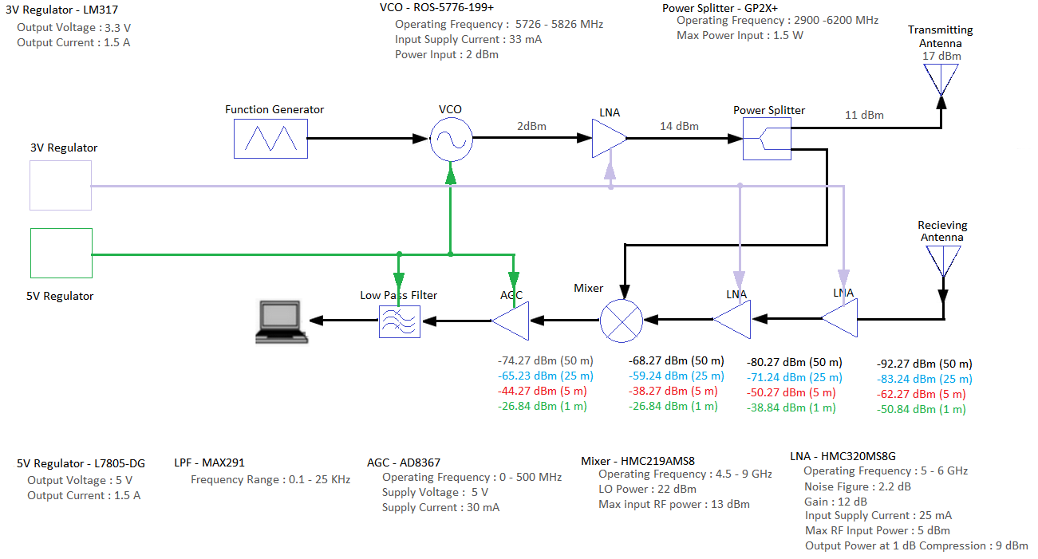

The triangular modulation signal is fed from the function generator into the VCO. The VCO acts as a source signal electronic oscillator controlled in oscillation frequency by the voltage input. The frequency modulated signal output from theVCO is then amplified and sent through the power splitter. The power splitter divides the signal into two channels: Transmitted signal and LO reference. The transmitted signal is sent to the antenna where the radiated electromagnetic waves of the transmitting antenna illuminate on the targets. The reflected waves are then sent to the receiving antenna. Because the RF signals received by the antenna are typically very weak, the signal is then passed through a low noise amplifier to amplify the signals. The signal amplified by the LNA is then mixed with the LO reference signal. The high frequency component $(f_{IF}=f_{RF }+ f_{LO})$ is filtered by the low pass filter at the IF output of the signal, and the modulated low frequency sinusoidal signal which is the frequency difference between the two mix signals $(f_{IF}=f_{RF }- f_{LO}$) is obtained through the output. The signal from the output of the mixer is sent through the AGC which provides a controlled signal amplitude as its output. This signal is then sent through the low pass filter and to the laptop for data processing.

It is important to note that this calculation assumes that an entire period does not pass in the time it takes to send out the transmitted signal, and the time it takes to receive the reflected signal. This can be altered by changing the frequency at which the input to the VCO ramps up and down.

**3) Component Selection:**

**General Considerations:**

Regardless of what type of component, there are a few key aspects that must be considered when deciding on which component to use.The first key aspect is the voltage supply. All active devices require DC supply voltage, and due to the restriction of only having one voltage supply, any DC voltage that wasn’t the supply voltage would have to be supplied by using an on-board voltage regulator. The on-board voltage regulator draws power, adds weight to the board, and can create overheating problems. Also, it is crucial to determine the power consumption of each component to decide if it is reasonable. For example, our group initially chose to use Linear Technologies’ active mixer, LTC5544, to mitigate the loss that a mixer usually incurs. However, for a conversion gain of 6.4dB, it consumed 640mW of power, which was not justifiable for this project.

When considering components for RF applications, it is important to consider the noise figure. The noise figure is the signal-to-noise ratio at the input to the signal-to-noise ratio at the output. Simply put, the noise figure is the amount of noise a component will add to the system. Components with low noise figure should be placed in the beginning of a cascade, due to the nature of noise figure and how the components early in the cascade effect all subsequent components in the cascade, as shown below.

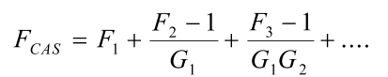

There are also basic considerations such as weight, power gain or loss, linearity, input and output isolation, input and output impedance, and heat generation (additional heat changes the operating conditions of a network, and can add additional, unwanted noise). Packaging type should also be considered when choosing a component. Selecting a component with an uncommon package will mean that when creating the layout for the PCB, the library will not contain that footprint. This was particularly an issue in KiCad, due to its relatively small library.

Finally, it is important to consider how easily obtainable certain components are. An example of this is another mixer our group considered, which was Analog Device’s HMC218AMS8E. The mixer specifications were suitable for our design, but it was “obsolete,” so it was no longer manufactured. However, it still may be available for purchase on distributor websites, such as DigiKey. Also, if a component is deemed “obsolete,” there is most likely another component from the same manufacturer that is very similar to that component. Indeed, there was an HMC219AMS8E, which was very similar to the originally considered mixer, and was a suitable replacement.

Ease of obtaining a component can also refer to if it is possible to sample it. Many manufacturers provide samples for their components, especially for educational purposes. Four companies that provided our group with free, sampled, components are Maxim Integrated, Analog Devices, Minicircuits, and Hittite. Minicircuits requires contact with HR to obtain samples, while Maxim, Analog Devices and Hittite have an automated system for samples. It is important to note companies such as Digi-Key are distributors, and as such, do not provide samples.

**Voltage Controlled Oscillator (VCO):**Minicircuits // ROS-5776-119+:

The RF signal used in the radar is created by the VCO, so choosing an appropriate VCO is essential to the success of the radar. One of the most essential aspect of consideration when choosing our VCO was the tuning sensitivity. When using the radar for distance measurement, we are ramping the tuning voltage linearly up and down. We assume that because we are ramping the tuning voltage linearly, the VCO output frequency will also be ramped linearly up and down with time. However, this is dependent on the tuning sensitivity being flat, meaning the output frequency changes linearly with tuning voltage. As seen below, although the ROS-5776-199+’s tuning voltage was not entirely flat, its tuning voltage only deviated less than 10% over the relevant range of operation, which was accurate enough for the purposes of our radar.

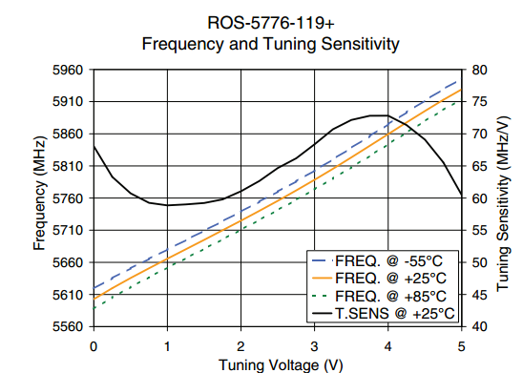

The VCO for the Doppler shift (velocity measurement) does not have to account for the tuning sensitivity, as we are sending a constant frequency signal. However, because we are using one radar for both purposes, the tuning sensitivity had to be flat for both purposes.

When considering a VCO, it is also critical to consider the phase noise. The phase noise of the VCO measures how constant the generated frequency is. Obviously, we desire a lower phase noise to have a cleaner signal. Using a Phase Locked Loop (PLL) would have reduced this phase noise, but due to our VCO already having a relatively low phase noise, we decided that it would not be an efficient allocation of our time.

Another key benefit to using the ROS-5776-199+ is the tuning voltage for the Doppler shift, which is a constant voltage, was approximately 3.3V for a 5.8GHz output signal. This was one of the voltages that was being used as a power supply.

**Function Generator:**Exar // XR-2206:

The VCO’s tuning voltage for the velocity measurement, as mentioned above, is a constant voltage. However, for the distance measurement, the tuning voltage is a linearly ramping signal. As we are only supplied with a constant DC supply source, we must create a triangle wave on the board. Initially, we were considering an Arduino (more specifically the Atmega328) for the low frequency signal generation. However, using an Atmega328 for only signal generation was a waste of size and power consumption. So, we decided to use the XR-2206 to generate the triangle wave.

**Mixer:**Analog Devices // HMC219AMS8E:

When considering a mixer, there is the option of choosing a single or double-balanced mixer. The single-balanced mixer will allow for a simpler design with a lower LO drive. The double-balanced mixer has a myriad of benefits including better noise protection, increased linearity, and better port isolation. However, a double-balanced mixer requires a balun (**bal**anced to **un**balanced) to convert the signal back to an unbalanced signal. Due to the difficulty of implementing a balun, we decided to use a single-balanced mixer.

Another key aspect of a mixer that cannot be overlooked is the port isolation. For the HMC218AMS8E, the LO to RF Isolation is 30 dB and the LO to IF Isolation is 25 dB. This means that if the difference between the LO and RF is over 30 dB, then there will be problems. However, if the difference between the two is greater than the isolation, it is still acceptable -- it will, however, suffer a degrade in isolation and therefore performance.

In our experience, we noticed that active mixers had a very large power consumption that could not be justified by its gain.

**Automatic Gain Control (AGC):**Analog Devices // AD8367:

After the mixer, we have our low frequency signal. The difference in frequency contains the distance or velocity information. However, to have the best processing of the signal, it is important to take advantage have the right amplitude. The AD8367 is very convenient because it does not set a constant output power -- rather it converts a range of input power to a constant 1Vpp For our signal processing, we are using our laptop as a A/D converter.

Shown below is the datasheet for our laptop’s sound card. As seen, the full scale input voltage is 1 Vrms. 1 Vpp is .353 Vrms. An A/D converter samples a certain amount of points over a certain range. This range is the full scale input voltage. Therefore, by having an input signal that is close to the full scale input voltage, we utilize the entire quantization range, and therefore minimize quantization error. However, it is important to note that we are doing frequency analysis -- utilizing the entire quantization range will provide a cleaner signal, but it is not necessary for processing.

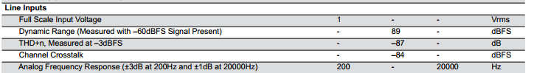

Shown below is us actually testing our laptop’s sound card with a signal generator. We started at a low input voltage, and eventually increased the input voltage, as seen in the jumps in amplitude over time. To our surprise, the input voltage saturated at 1 Vpp, and additional input voltage only added noise to the reading. So, the AD8367 was an even better option than previously considered, as the effective full scale input voltage was tested to be 1 Vpp, instead of the 1Vrms as advertised in the datasheet.

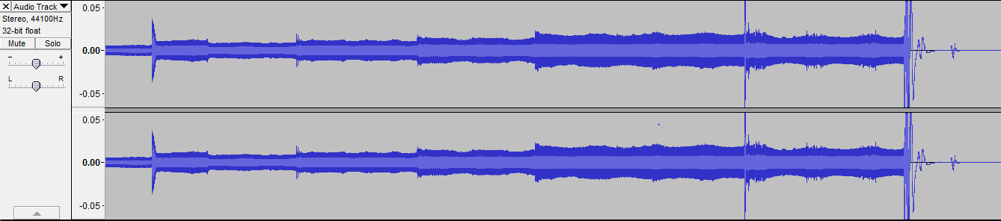

Another criteria we also had to consider when using our laptop was the sampling rate. Our input signal would be approximately 20 kHz, meaning that to completely process the signal, the sampling rate of the sound card would have to be at least the Nyquist rate, which is double the input frequency. The sampling rate for our sound card was 44kHz, meaning our laptop was suitable for processing.

**Low Noise Amplifier (LNA):**Analog Devices // HMC320MS8G:

LNA is very low noise, but at the cost of gain and linearity. As discussed earlier, a low noise figure early in the system is important due to the cascading nature of noise figure. For our system, this meant placing an LNA right after the VCO, and one right after the receiving antenna. We did not use a power amplifier (PA) because that would have provided our system with too much gain.

**Power Splitter:**Minicircuits // GP2X+:

Initially, our group was going to fabricate a 10dB coupler using techniques learned in the EEC132 series. This was based upon the fact that we wanted to use as little power as possible in the local oscillator drive of the mixer so we can have maximum transmission power. However, after reviewing the mixer datasheet, we learned that the mixer performance increases as the LO drive increases, as shown below. So, we settled with a splitter, which is a 3dB coupler.

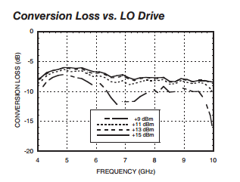

Also, fabricating a 10dB coupler ourselves would have resulted in slightly higher loss, noise figure, and size than what we could find if we were to have purchased an integrated circuit.

**4) Design Schematics:**

Baseband:

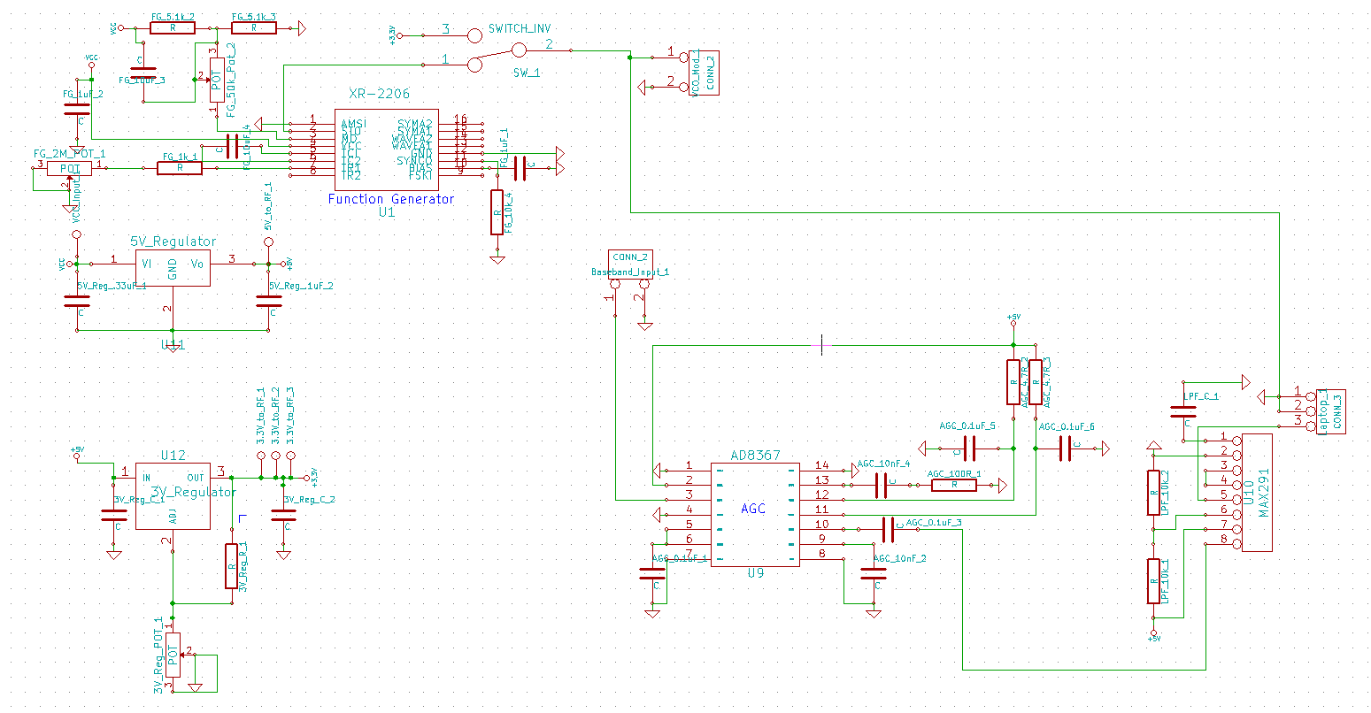

RF:

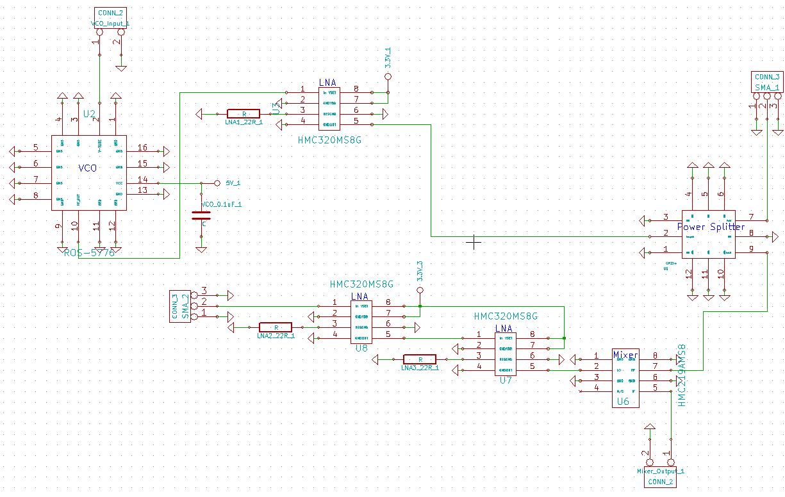

**5) Printed Circuit Board designs:**

Shown on the left is the baseband board, and on the right is the RF board. Shown below that is how the RF board rests on top of the baseband board using pin headers. The pin headers also feed low frequency or DC signals between the two boards.

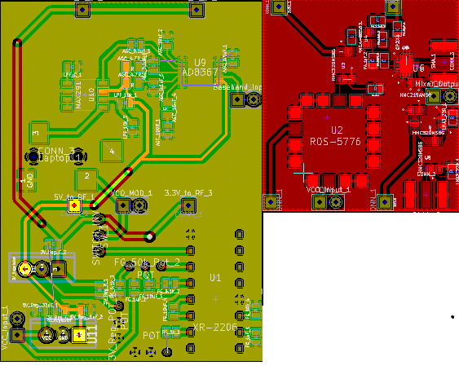

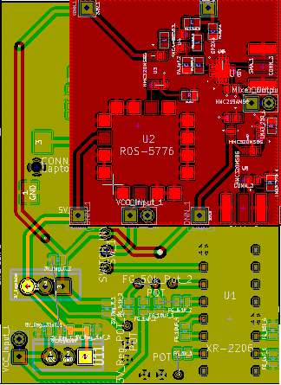

**6) Testing the system:**

When testing the RF signals, it is very difficult to isolate the cause of an error within a system. Unlike baseband signals, there is no easy way to probe the system to measure an RF signal. This is due to reflections caused in high frequency circuits if there is an impedance mismatch. This became a very significant fact when the transmitted signal was read at -19.76 dBm, instead of the expected 11dBm. After testing the cable used, we found that there was a 5dB loss at the center frequency, meaning that the actual signal being transmitted was -15 dBm. However, the signal was supposed to be 11 dBm, meaning there was a loss of 26 dB. 26 dB converted to an absolute scale is approximately 400, meaning almost the transmitted power was 400 times smaller than expected, meaning the output signal was not sufficiently powerful enough to transmit a recognizable signal. Shown below is the output at the transmission port, and the test setup that we used to measure the transmission output.

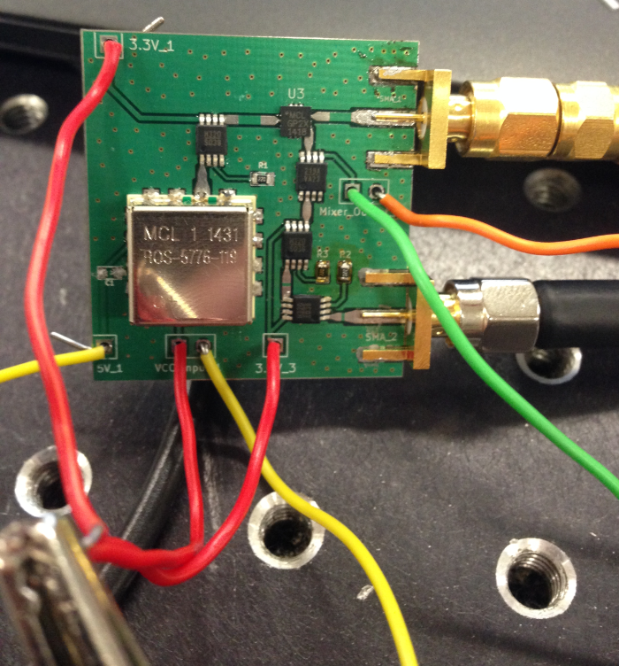

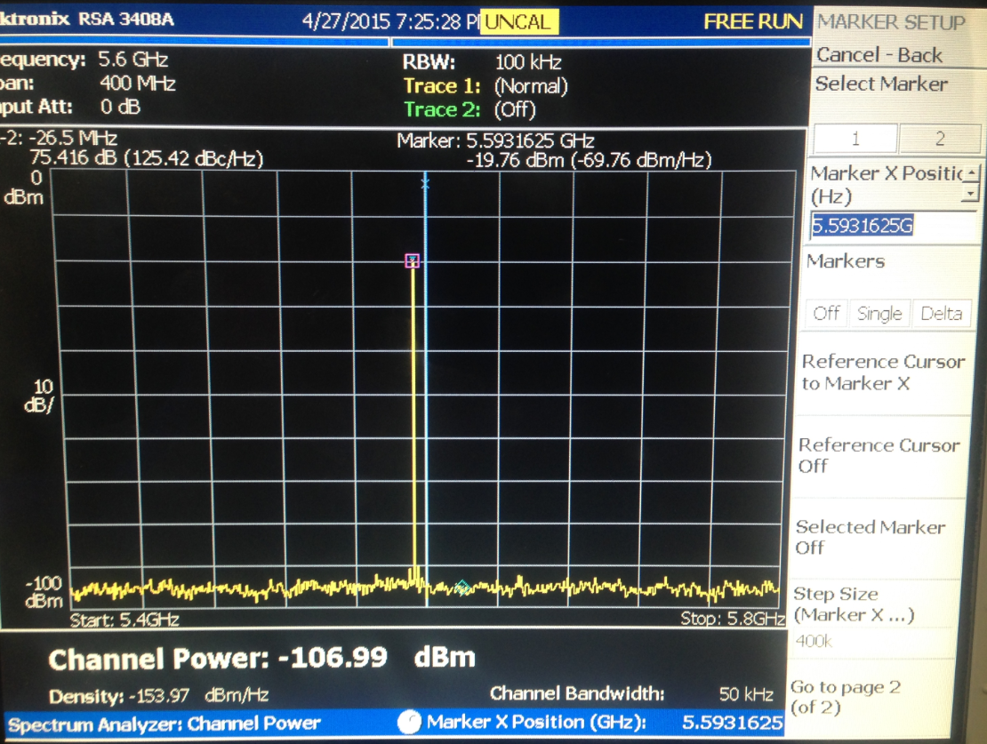

The next step in the testing process is to find the cause of this loss. To do this, we tested the relevant components individually to see which component was not drawing power. If one of the components was drawing insufficient or no power, we could definitively say that is one of the causes. We cannot, however, claim that it is the only cause. Shown below is an example of how we measured the power draw from each individual component. Notice how there are no other components on except for the LNA and the resistor, which was necessary for the LNA’s functionality.

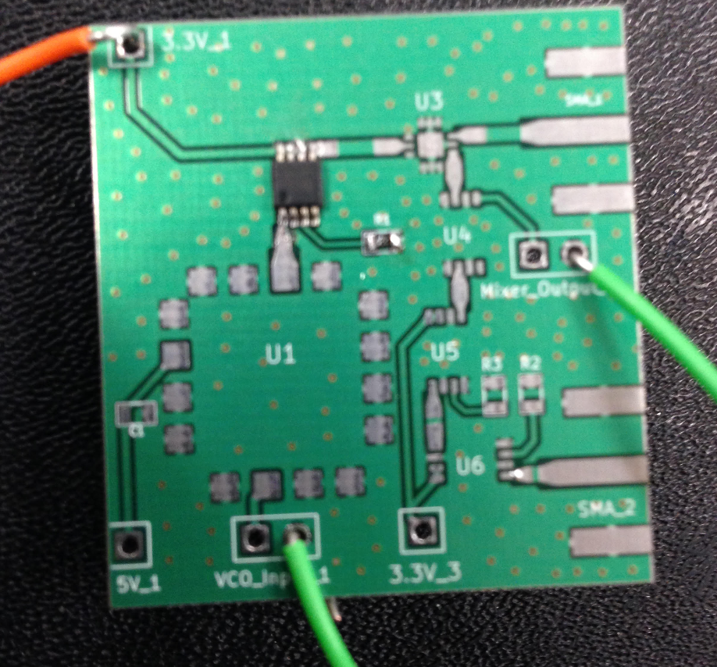

For the case of the transmitted power, we had to test the VCO and the first amplifier. To measure the power, we read the voltage and current that was being drawn from the power supply. For the VCO, it was drawing 20mA at 5V, and the LNA was drawing 30mA at 3.3V. That is 100mW and 99mW, respectively. The expected value is 33mA (max) at 5V (165mW), and 25mA at 3V (75mW), respectively. This was well within the expected range, especially when considering the power supply can only read in 10mA intervals, resulting in non-exact results. For our purposes, however, this was more than accurate enough, as it proved that the component was drawing a component that implied the component was properly connected and functional.

So, from the previous test we were able to conclude that it was not the active components that were the problem. So, we were able to narrow the likely causes of error to: faulty coplanar waveguides, faulty soldering, or the splitter. The splitter is not an active device, so the biasing could not be the problem. The difficult part of the splitter was the type of footprint it has. The VCO and splitter both are from Minicircuits, whose pads are below the component (as opposed to, for example, a SOT package which has legs extending outwards for easier soldering) meaning that it was not only very difficult to solder, but hard to check if the solder was done correctly. This problem was magnified by the very small package of the splitter.

As we were not able to discover the exact source of the problem, we were not able to have a fully functioning radar. From what we did have, the transmitted signal was too weak for our radar system to pick up a signal strong enough that could be demodulated.

**7) Designing the Antenna:**

The antenna is a rectangular microstrip patch antenna with two parallel slots incorporated which forms the E-shaped. The slots perturb the surface current path introducing an inductive effect that causes the excitation of a second resonant mode. By introducing a second resonant mode, the two resonates couple to form a wider bandwidth necessary for the radar application. The frequency that the VCO outputs is a function of time for the distance measurement, so the antenna must have a relatively large bandwidth.

The E-shape microstrip patch antenna has been designed to operate at 5.8 GHz. The antenna was designed on Rogers RT/duroid 5880 Laminates substrate with a dielectric constant of 2.2 and a height of 3.125 mm.

In this design, all dimensions of the E-shaped patch antenna are calculated and optimized. The improved results of the patch dimensions are shown in the Table.

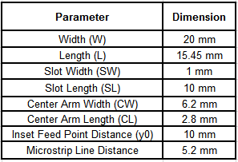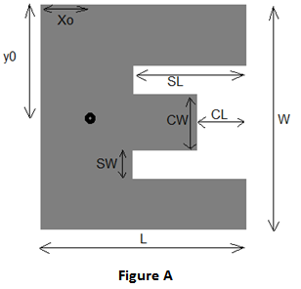

Simulations were performed using the software High Frequency Structure Simulator (HFSS). This software was used to calculate parameters such as return loss gain, bandwidth, VSWR, and various other parameters.

**Testing the Antenna**

The E-shaped Patch Antenna was fabricated using the milling machine. The milling machine uses a milling cutter to remove material from the surface of a workpiece. The final antenna fabrication is shown in Figure G.

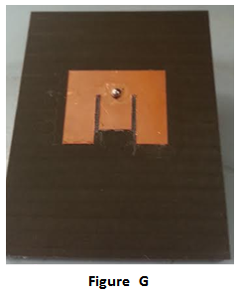

For measurements, the network analyzer was used to calculate the S11 also known as the return loss of the fabricated antenna.

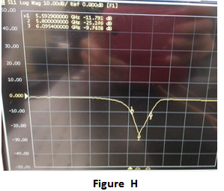

The return loss of the fabricated antenna is -25.24 dB at the resonant frequency of 5.8 GHz. The fractional bandwidth of the fabricated antenna spans from 5.59 GHz to 6.0954 GHz which is a fractional bandwidth of 8.713%. Good agreement between the simulation and measurement of the fabricated design was observed.

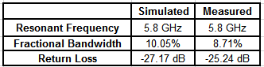

The fabricated antennas were also tested using the anechoic chamber. The antenna was rotated from 90 degrees to -90 degrees in the anechoic chamber to measure the gain in terms of S21. Figure I shows the antenna measurements in the anechoic chamber.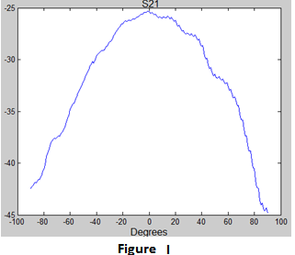

The fabricated antenna resulted in the correct shape of the S21. Though the gain is at -25 dB during measurement, after some investigation, the calibration was not set properly and resulted in an obscure gain value.

The fabricated inset fed E-shaped microstrip patch antenna was designed and simulated at a resonant frequency of 5.8 GHz. The antenna resulted in an input return loss of -25.24 dB and a gain of 6.041 dB. An effective bandwidth of 8.713% was obtained (5.59-6.09 GHz). The overall performance of the antenna is more than meeting the demanding design specifications necessary for the radar application.

**8) Possibility for future extension:**

If there was a possibility for future extension, the primary goal would be to get our radar system to be functional. Through testing the design, we were able to determine the most likely causes of the output signal not transmitting a sufficiently strong signal. We would proceed to develop another iteration of the design in order to try to resolve the issues that we currently have with our initial board. Another potential addition to the design would be to implement the antennas onto the printed circuit board, the antenna design would be sent in with the printed circuit board in order to lower the weight and make the overall design smaller. This would also improve the accuracy of the antenna. The main issue with this, however, is that it would make it even harder to test the antenna’s output. We would not be able to measure the output directly using an SMA cable, but rather we would have to take measurements in the anechoic chamber.

If we were able to start this project over from the beginning, we would have started with a prototype board made with the pure intention of seeing whether the entire board is connected properly. This would be done by adding couplers throughout the board. By implementing 5-10 dB couplers throughout the board, we would be able to accurately measure the RF output power at key positions in the board. As of now, we are only able to measure the RF output power at the transmitted port, as there is a SMA cable there. By utilizing couplers with a rather large coupling, we could couple only a small amount of power for testing purposes. The relative power can be used to approximate the exact power that is actually being outputted from the RF components. Of course, for the final edition of the board, we would take out the coupling, without changing the other aspects of the board. This, in theory, should reduce the amount of theorizing and guesswork involved in trying to find the exact cause of an unexpected error, such as having low output power.

**9) Suggestions for the class:**

During the first quarter we focused on learning how components such as mixers, voltage controlled oscillators and amplifiers worked on a week by week basis. Some of the time allocated to each of these labs could have been condensed into shorter, one week labs in order to allow students to have more time to begin planning on how to improve their FMCW radar systems. This would be extremely helpful as students may be able to begin designing and building their radar system at the end of the first quarter to get started for their final design. This could give students time to send in multiple iterations of their printed circuit boards in case their first try does not go as planned. Also, the final lab was many times longer than the other labs, and the entire process could have been smoother if were allotted more time for that lab.

As for the weekly meetings, we believe that the class could benefit from the weekly meetings being changed to be once every two weeks. Having meetings every week can be helpful, but can also result in a high pressure environment where groups feel pressured to create elaborate reports and presentations, rather than actually progress on the design. Meetings every two weeks allow for students to progress further and present more information to the class.

Another approach to alter the weekly meetings is to change it from a presentation style to a more discussion based meeting. As of now, we feel that many groups were primarily focused on delivering the best presentation for the weekly meetings. While this can be a positive learning experience, in reality it resulted in what we felt were meetings where many groups displayed disinterest in what the other groups were presenting. This is highlighted by the fact that most groups left after they gave their presentation. We also saw that many groups that had not reported yet that day were working on their presentation while other groups were presenting. We feel that by changing the discussion section to more actively involve the entire class, we could have a better possibility for a more fluid exchange of ideas, while at the same time creating a lower stress environment.

**10) Conclusion:**

For most of us in this group, it was our first time being involved in an engineering project, particularly of this length and magnitude. As such, the senior design class because an environment that facilitated the learning of the engineering process which most of us were unaware of previously. In this senior design, we learned how to develop a plan to complete a project, and how to respond when outside factors force us to deviate from the original plan. The senior design class acted as a catalyst the forced us to not only develop our technical skills, but also forced us to improve our interpersonal and organizational skills.

By having the freedom to build a system completely independent of the prototype radar built in fall quarter, we had the responsibility of learning every important aspect of every component in our radar. When building the prototype radar, we had every component chosen for us and we were guided step-by-step on how to build a functional radar. Not only did we have to determine which component to choose, we also had to figure out if the component was necessary at all. This gave us an opportunity to think more dynamically and gave us a better fundamental understanding of how the radar system works, allowing us to more efficiently optimize the design. By familiarizing ourselves with the different aspects of every component such as noise figure, linearity and gain, as well as different types of components such as single and double-balanced, we were forced to make critical decisions that directly impacted the success of our radar. We learned not only how to weigh the benefits versus the costs, but we also learned how to identify the pros and cons to more accurately conduct the cost-benefit analysis. In the most basic sense, this generally refers to the ability to read through a component datasheet and compare specifications that allows for the most efficient radar. However, we also learned of the less obvious cost-benefit analysis, such as how difficult it would be to properly solder a component which is very small, and has its pads underneath itself. While this is not too much of a big deal, it was one aspect of the testing process that took a long time and patience. These critical decisions of being able to properly identify and conduct cost-benefit analysis is, what we believe, a key skill in becoming a more well-rounded engineer.

Our group was able to learn many specific RF skills that we were not able to learn in our undergraduate courses at UC Davis. Whether that was from studying research papers on how to create antennas with wider bandwidths, or reading hundreds of datasheets to learn of the finer details of RF electronics, we were able to develop a more comprehensive understanding of the applications of our studies in RF and electrical engineering. Every member of our team also gained the experience of overcoming adversity within the team -- whether that was not being able to agree when to work, or how the group should be run -- we were able to overcome our differences and learn how to solve problems by listening to each other, and negotiating a solution that everyone in the team could agree with. After working with a group for such an extended period of time, we all found a newfound respect for each other's opinions and capabilities, which we believe is a key in being a capable leader. Despite not being able to build a fully functioning radar, we believe that the critical thinking skills and leadership skills obtained from this senior design project will prove to be quintessential in our transition from student engineers to professional engineers.